BLOOMSCAPES MAY BASKETS
from Weston Media and the Weston Garden Club.
The image in the center below can be used as a gift tag for your basket. Watch the video here.
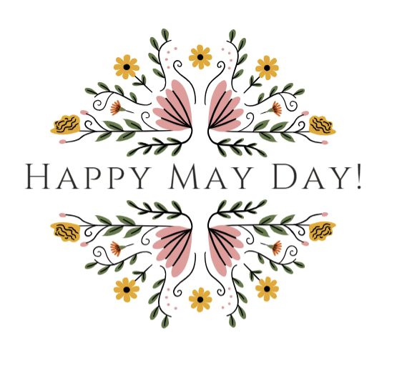
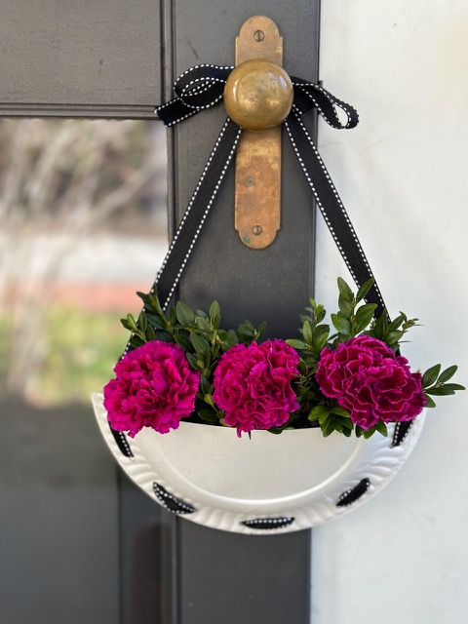
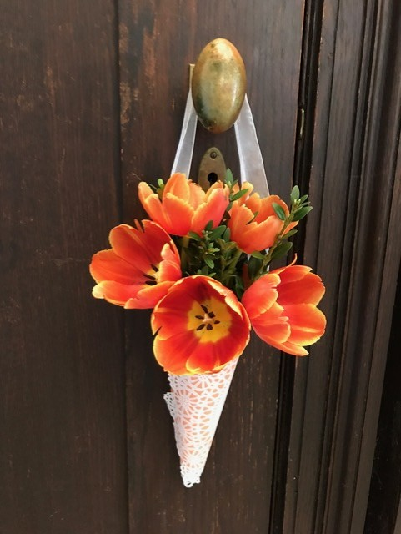
Listed below are ideas to get you started.
Basket Materials:
Paper Baskets – To create a paper basket we suggest using paper plates, doilies, calendar pages, wallpaper samples, or any other paper you like. We like to use a glue gun, tape, or stapler to secure the shape of your basket. Ribbon and a hole punch work well to make a handle for your basket.
Man-made baskets – Check your recycling for glass or tin containers or find small baskets, pretty boxes, or glass containers in your home.
Floral Materials:
Check your yard for greens and flowers. We love using boxwood, Andromeda (Pieris), or pine for green then, add some color with daffodils, rhododendrons, or any other items blooming in your yard. We also like picking up a colorful bouquet from a grocery store.
Cutting:
Floral scissors for flowers, paper scissors for paper, and clippers for cutting from your yard.
Holding flowers together in a basket:
We like to use rubber bands, ties, or floral wire to hold flowers together which is particularly helpful when delivering flowers, so they do not fall out of your baskets. In a large basket, we place tissue paper in the bottom to help fill the bottom of the basket and then place secured flowers on top of the tissue paper.
Floral water source:
To keep flowers fresh, we use a zip lock bag with a wet paper towel wrapped around the ends of the cut floral stems or insert flowers into floral tubes filled halfway with water. A plastic cup with water can be inserted into some types of baskets too.
Decorations for basket: Stickers or a Happy May Day Sign (at the center top of this page).
We cannot wait to see the baskets you make! Please share pictures or ask questions on our Instagram page @wgceveninggroup.
Presenters: Dana Christensen and Kirstin Schena
westongardenclub.org 